**MODULE 1 - RELATIONAL DATABASE CONCEPTS**

**Fundamental Relational Database Concepts**

**Review of Data Fundamentals**

* Data is information like facts, observations, perceptions, numbers, characters, and images that can be processed to become meaningful.
* Data can be structured, semi-structured, or unstructured.
* Different data sources offer different types of data, for example data from social media can be unstructured or semi-structured.
* Data can be stored in repositories like relational databases and non-relational databases, amongst many others.
* Data can be transferred in CSV, XML, and JSON files.

**Information and Data Models**

* Information Models are abstract, formal representations of entities that include their properties, relationships and the operations that can be performed on them.
* Data Models are defined at a more concrete level, are specific and include details.
* The Relational Model is the most used data model for databases because this model allows for logical data independence, physical data independence, and physical storage independence.
* Entities are objects that exist independently of any other entities in the database.
* Entities can be a noun (person, place, or thing), such as a book or an author. Attributes are the data elements that characterize the entity. For example, the book entity will have attributes like author and title.

**ERDs & Types of Relationship**

* The building blocks of a relationship are entities, relationship sets, and crows foot notations.
* In a one-to-one relationship, one entity is associated with one and only one instance of another entity. For example, when one book has only one author.
* In a one-to-many relationship, one entity is associated with one or more instances of another entity. For example, when one book has many authors.
* In a many-to-many relationship, many instances of an entity are associated with many instances of another entity. For example, when many authors write many different books.

**Mapping Entities to Tables**

* Entity-Relationship Diagrams (ERD) are the foundation for designing a database.
* To translate an ERD into a relational database table:

1. The entity becomes the table
2. The attributes become columns in the table

**Data Types**

* Data types define the type of data that can be stored in a column.
* There are many different data types for all kinds of data.
* Using the correct data type for a column has many advantages.

**Relational Model Concepts**

* Relational Model of data is based on the concept of relation
* Relation is a mathematical term for table
* Degree refers to the number of attributes (columns) in a relation
* Cardinality refers to the number of tuples (rows) in a relation
* A Relation Schema specifies the name of a relation while a Relation Instance is a table made up of the attributes (columns) and tuples (rows)

**Introducing Relational Database Products**

**Database Architecture**

* Databases are deployed in different topologies, depending on which best suits the processing and access requirements.
* A single-tier topology is one where the database is installed on a user’s local desktop. It is useful for small databases that only require single user access.
* In 2-tier database topologies the database resides on a remote server and users access it from client systems.
* In 3-tier database topologies the database resides on a remote server and users access it through an application server or a middle-tier.
* In Cloud deployments the database resides in the cloud, and users access it through an application server layer or another interface that also resides in the cloud.

**Distributed Architecture and Clustered Databases**

* In shared disk database architectures multiple database servers process the workload in parallel, allowing the workload to be processed faster.
* In database replication changes taking place on a database server are replicated to one or more database replicas.
* In a single location database replication provides high availability. When a database replica is stored in a separate location, it provides a copy of the data for disaster recovery.
* In partitioning, very large tables are split across multiple logical partitions.
* In sharding, each partition has its own compute resources.

**Database Usage Patterns**

* Three main classes of users are:

1. Data Engineers
2. Data Scientists and Business Analysts
3. Application Developers

* Databases can be accessed through:

1. Graphical and Web Interfaces which make it easy to interact with the database visually.
2. Command line tools and scripts can be cumbersome to use but are powerful in the hands of an experienced Data Engineer and help with automating repetitive tasks.
3. APIs and ORMs which help application developers create applications that access a database on behalf of a user or client application.

* Major categories of database applications include:

1. Database Management tools like phpMyAdmin (MySQL DB) or pgAdmin (PostgresSQL DB).
2. Data Science and BI tools like Microsoft Excel, IBM Congos, and MicroStrategy, which enable Data Scientists and Data Analysts to analyze data and produce targeted reports.
3. Business and Industry applications for tasks such as e-commerce, supply chain, etc.

**Introduction to Relational Database Offerings**

* Relational databases are available with commercial licenses from companies like IBM, Oracle, and Microsoft.
* Open-source relational databases are offered with a variety of licenses that make them free to the user.
* The popularity of open-source relational databases has risen to approximately 50% in the past decade.
* The popularity of Cloud databases has more than doubled in the past decade.

**Db2**

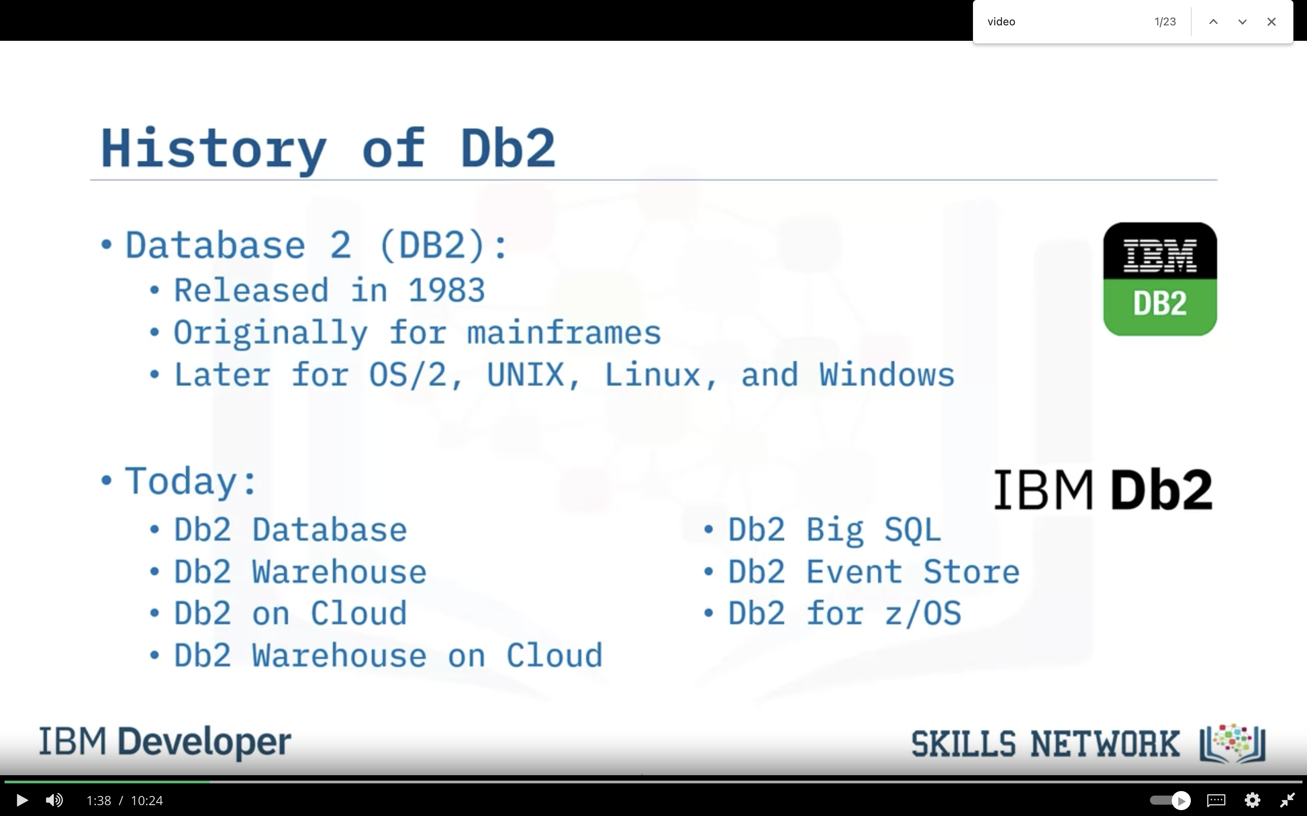

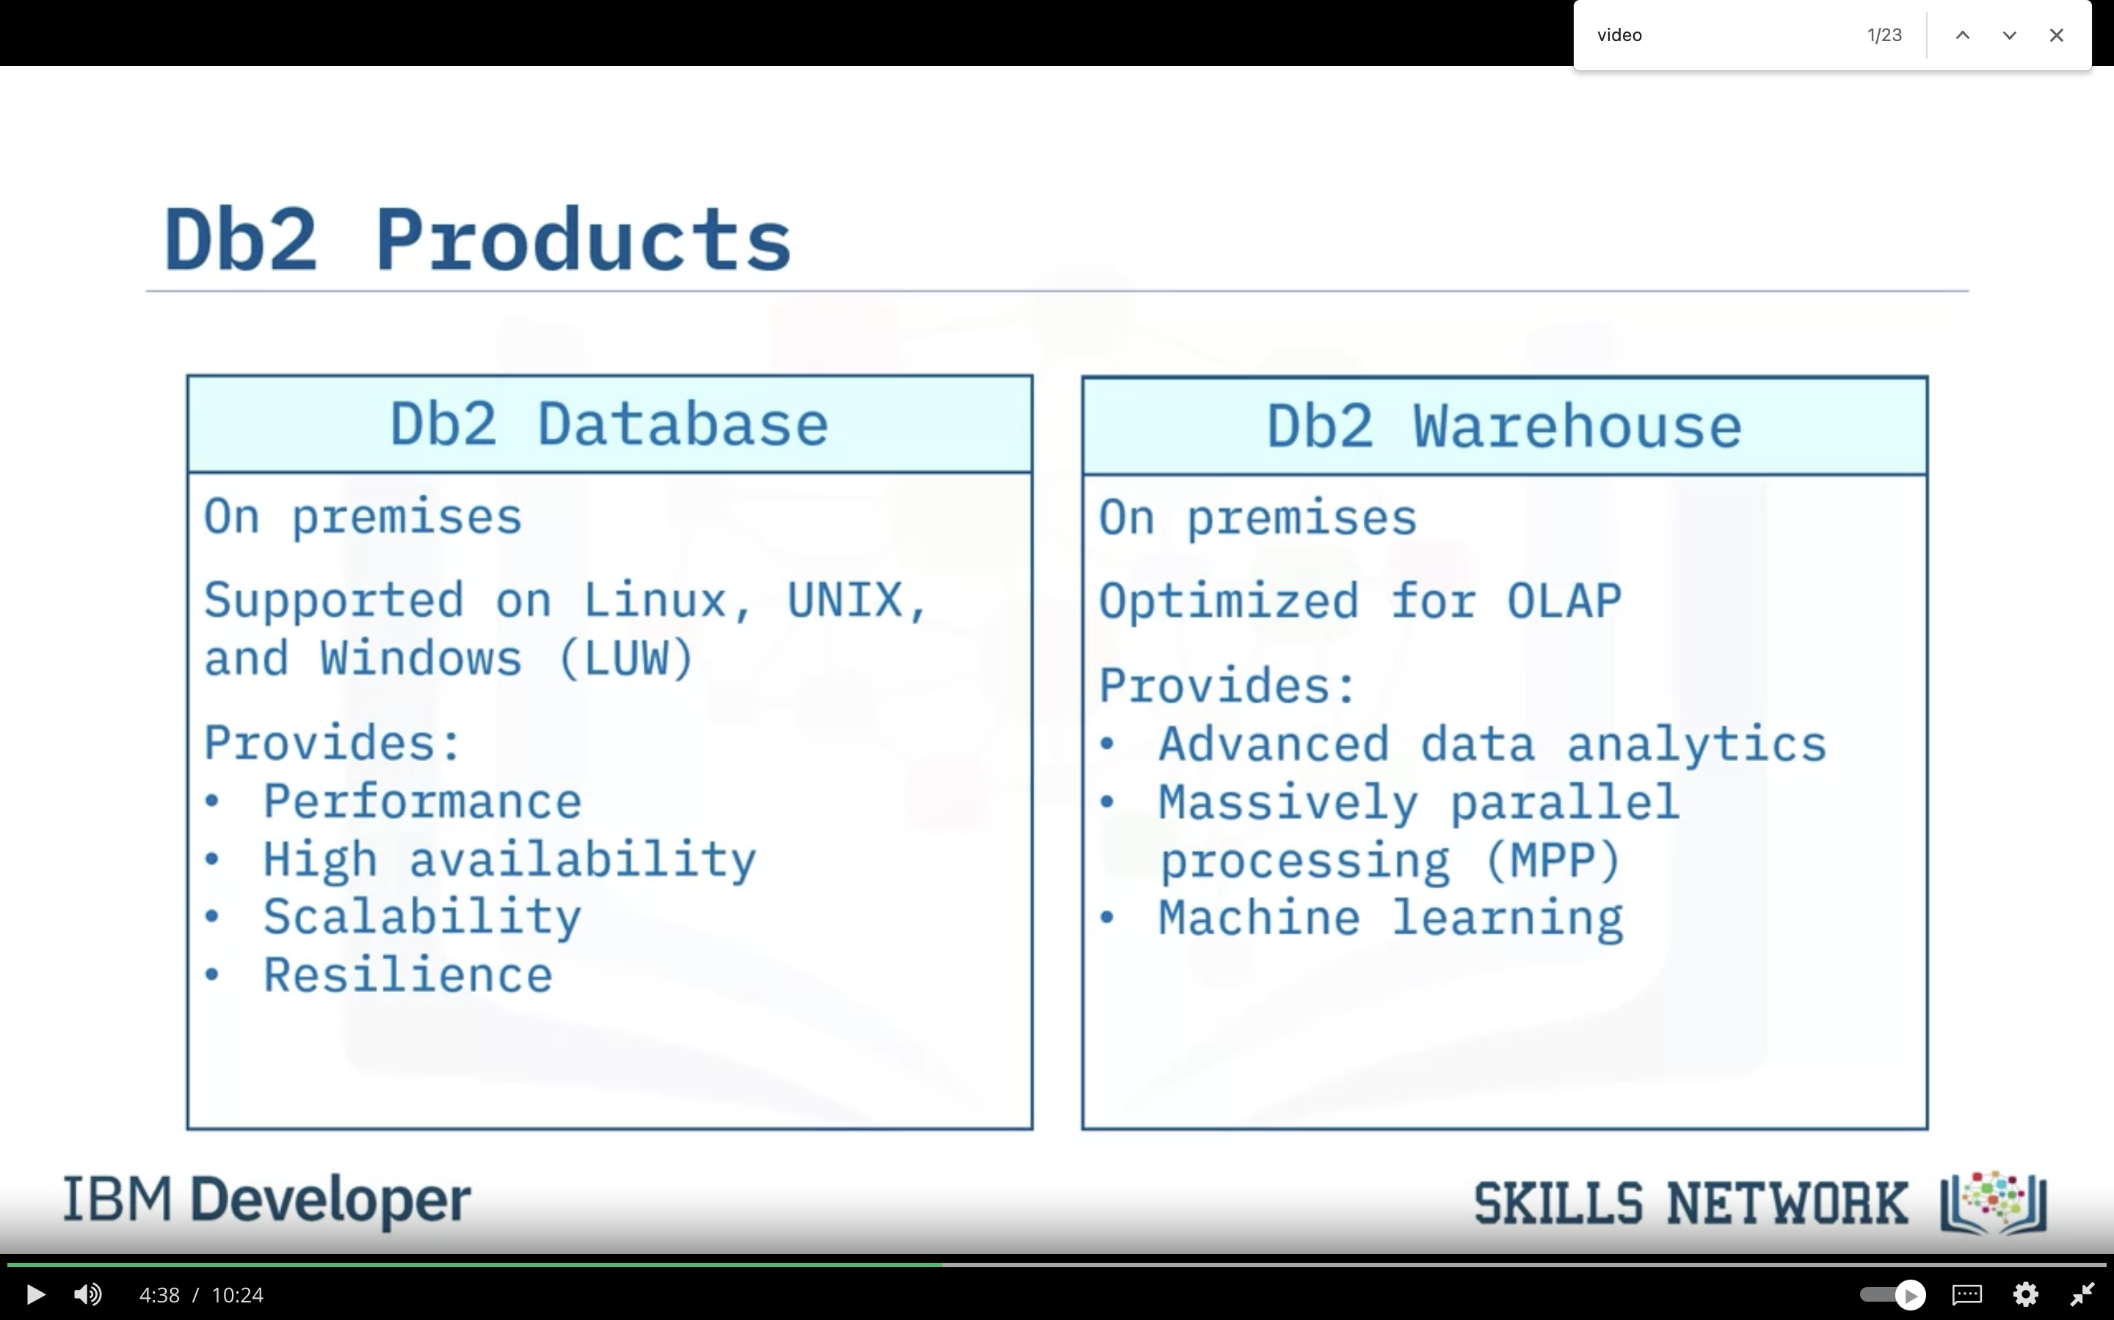

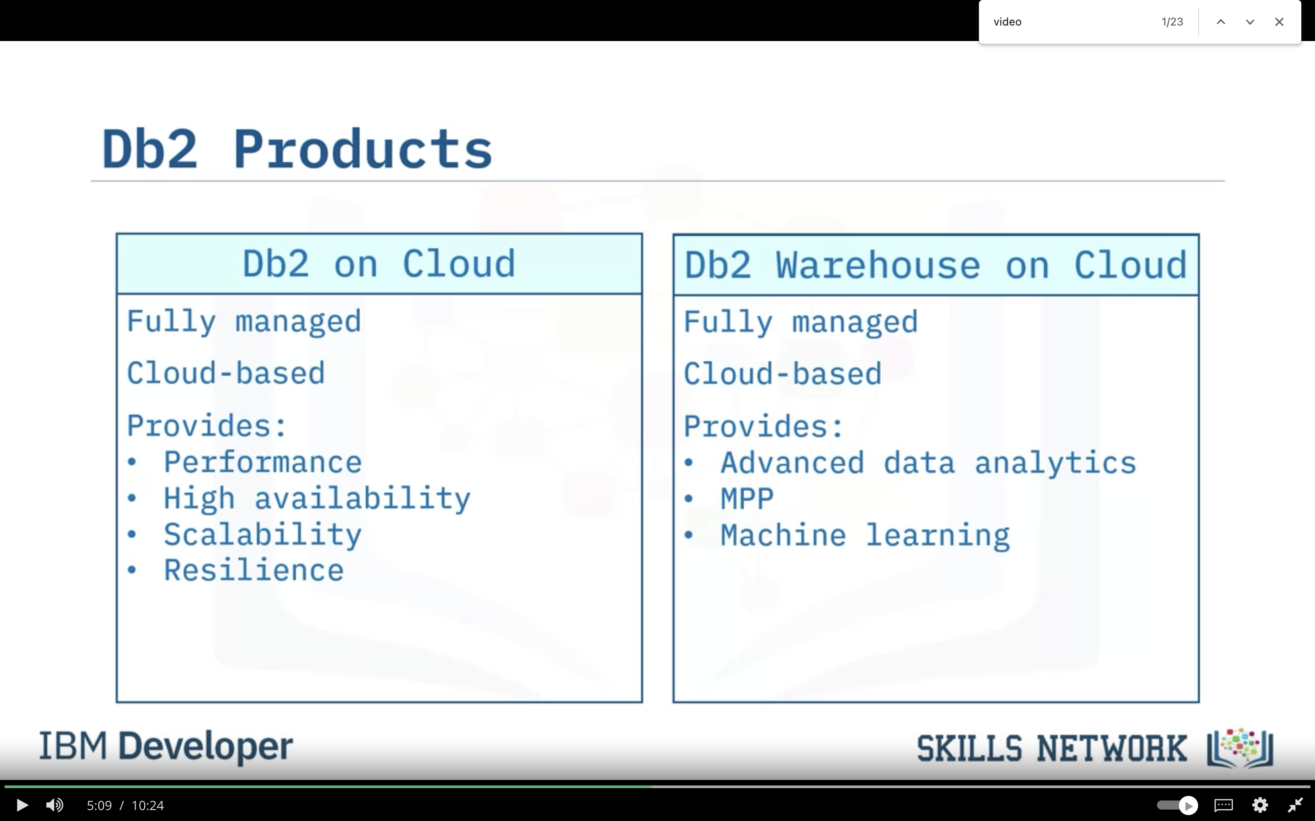

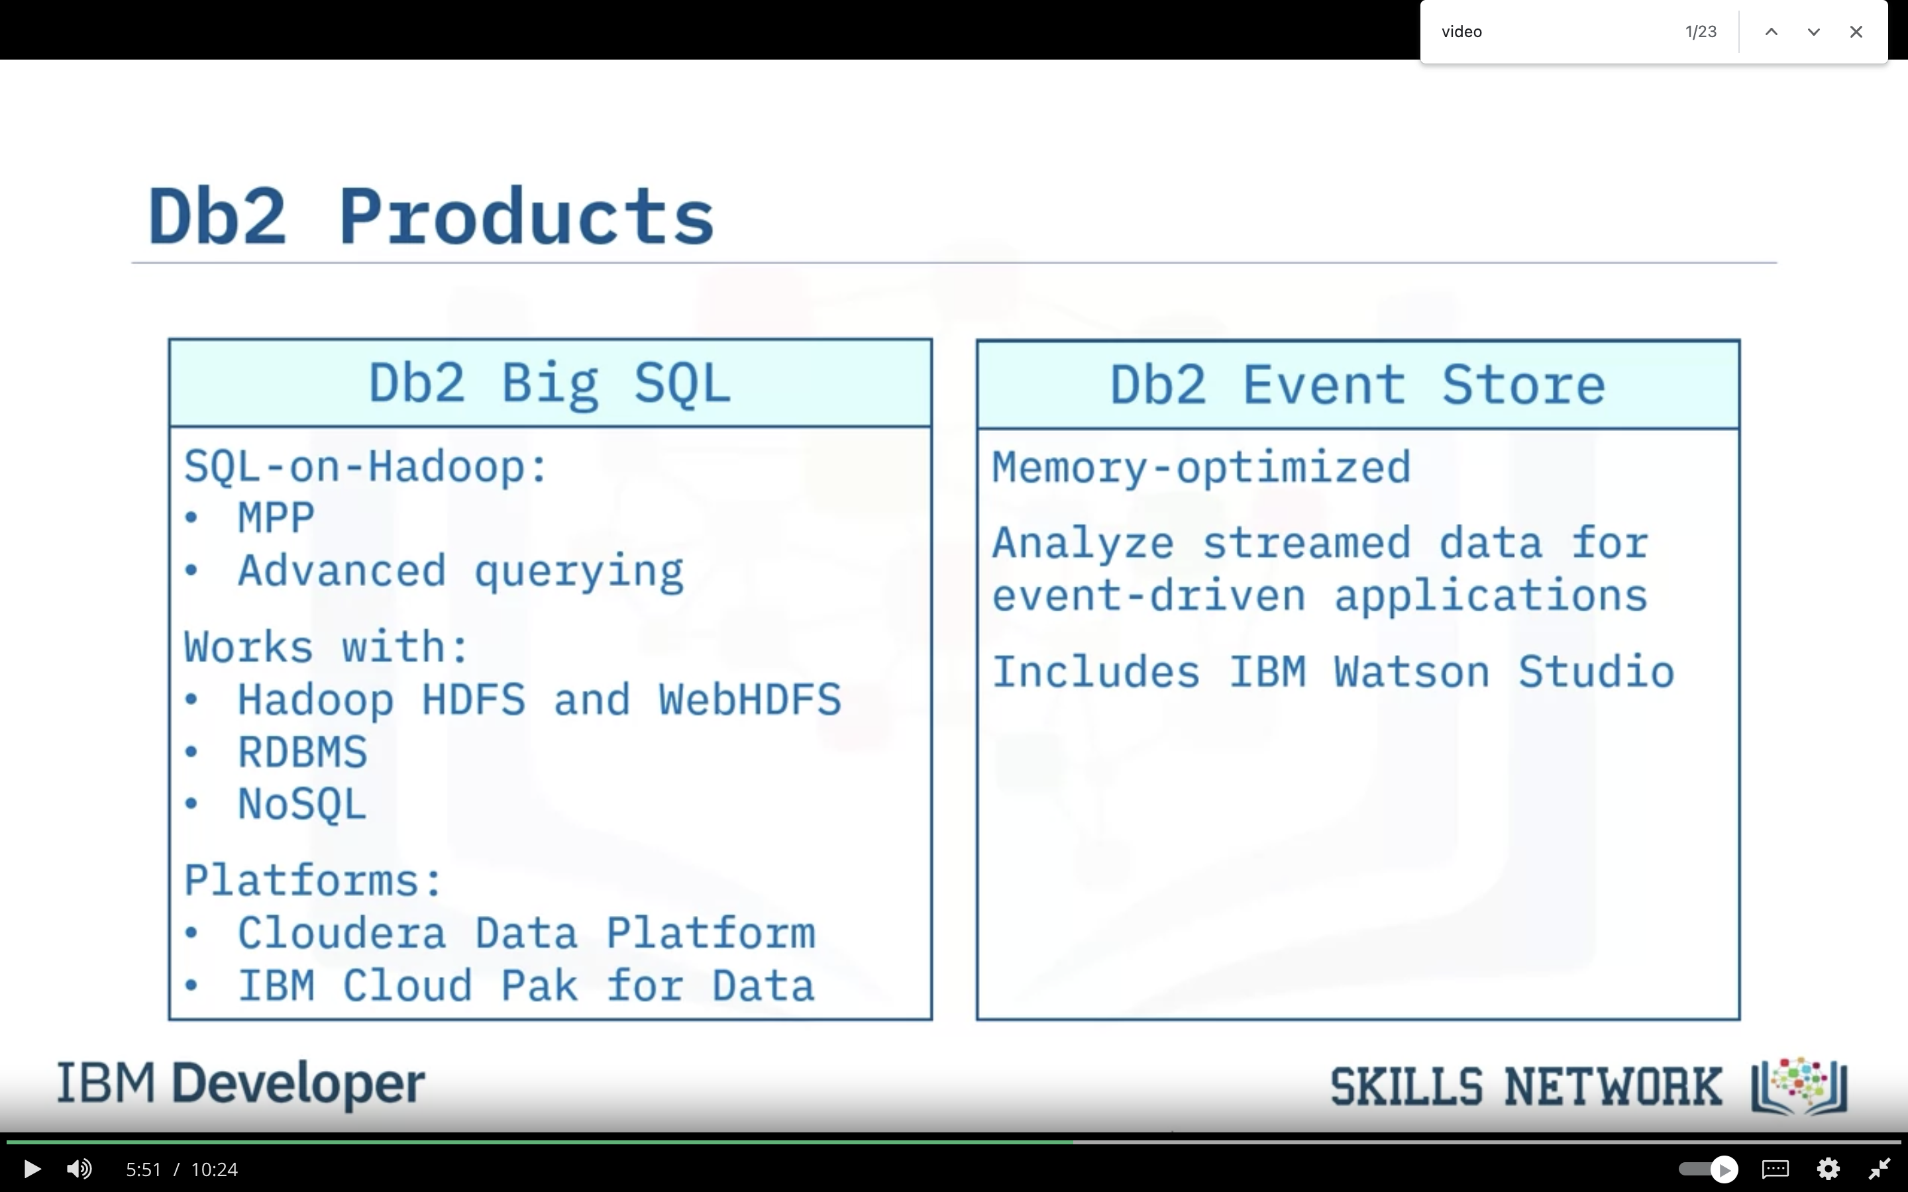

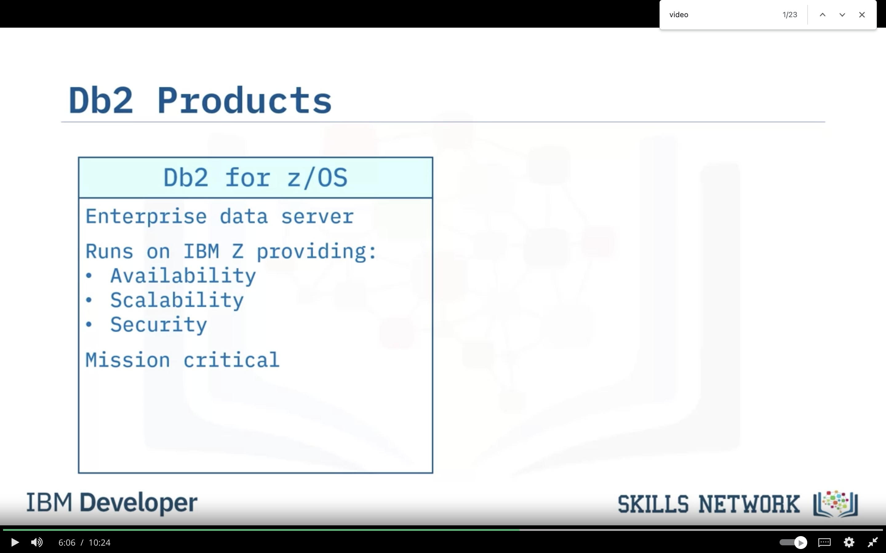

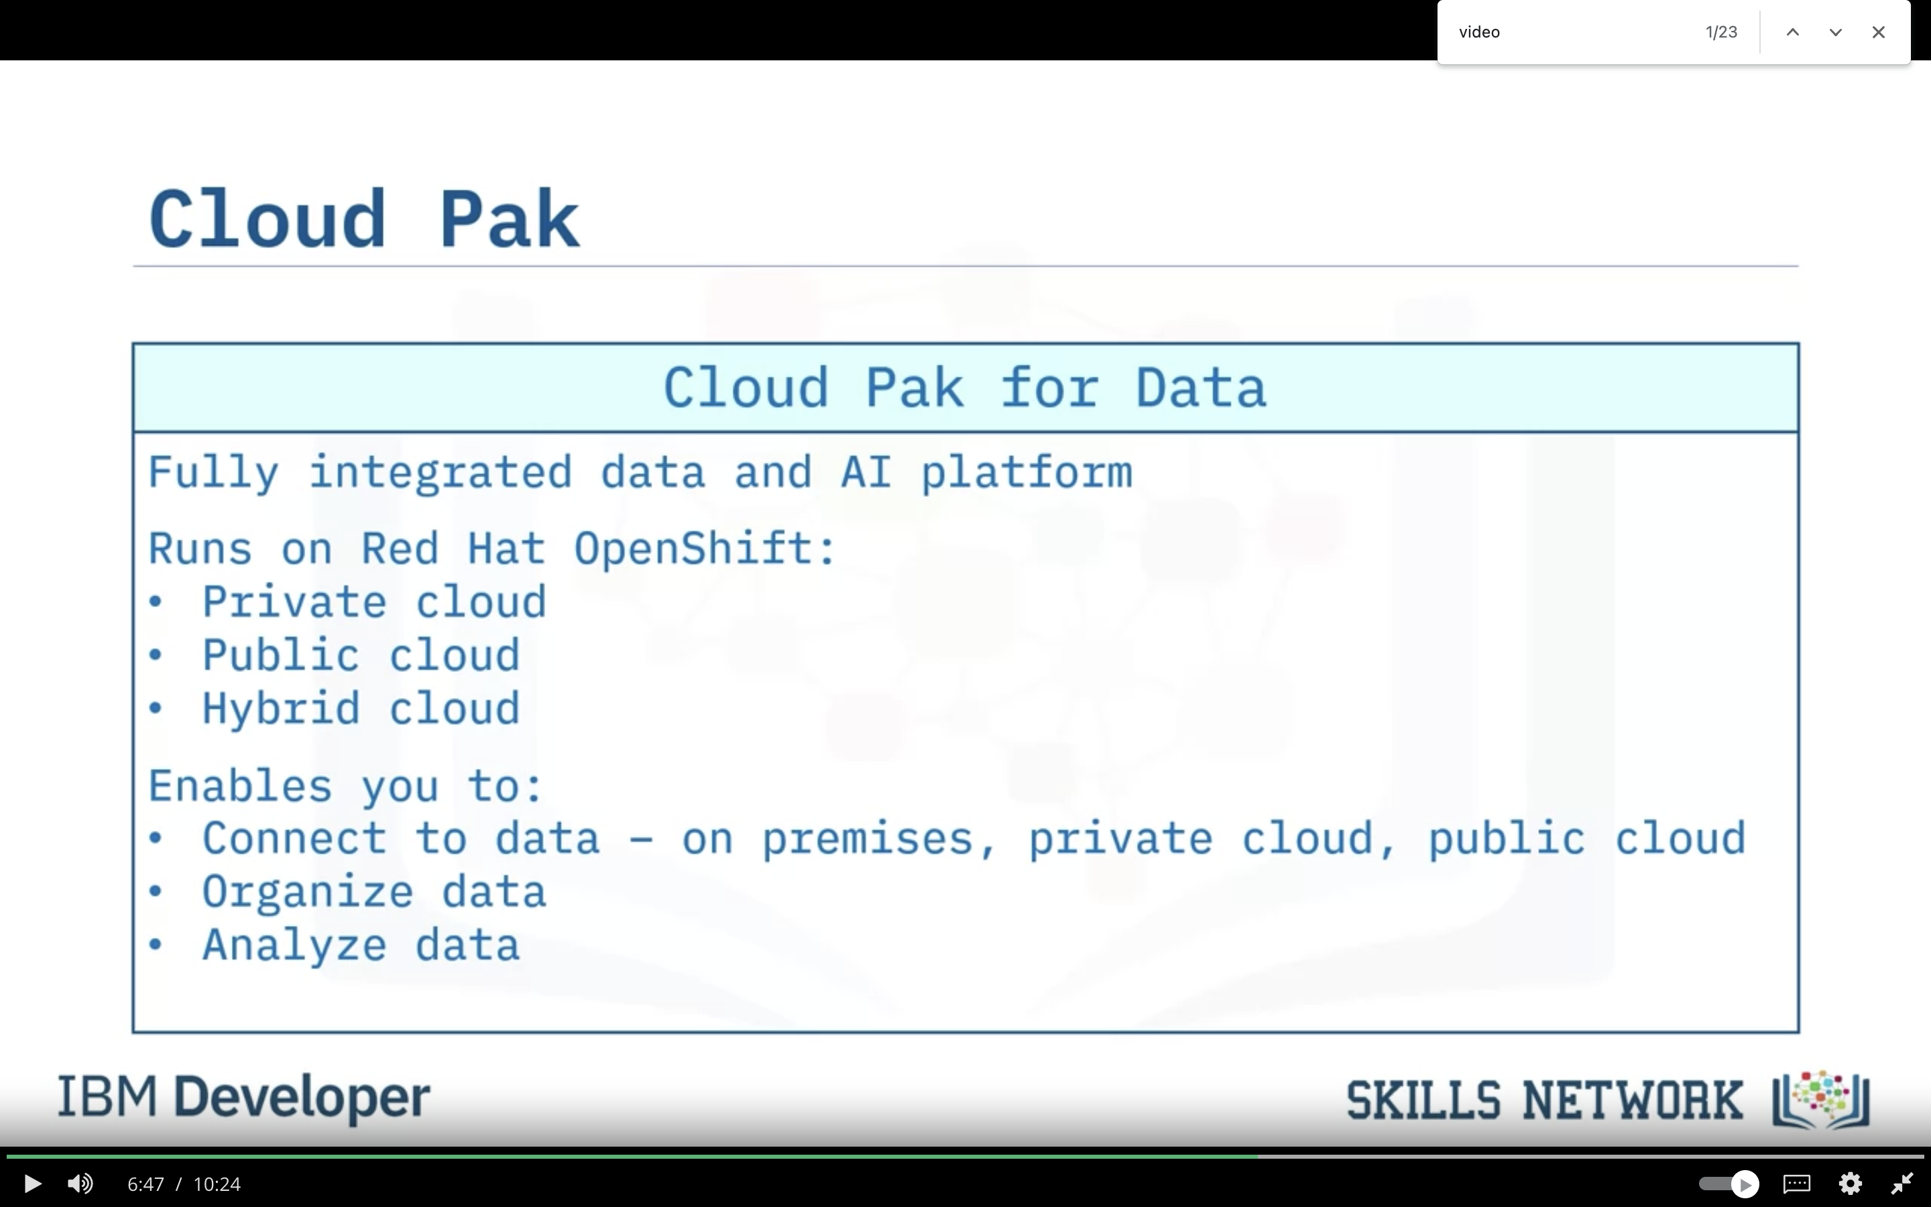

* Db2 is a family of products that you can use to work with and manage your data in whatever way you need
* You can deploy Db2 across many platforms, both on premises and in the cloud
* Cloud Pak for Data includes Db2 and many IBM tools for data
* Db2 on Cloud is a fully managed, cloud-based SQL database that can run on IBM Cloud or AWS
* Db2 provides high availability, disaster recovery, and scalability functionality

**MySQL**

* MySQL is an object-relational database, available in various editions
* MySQL supports many operating systems
* MySQL supports a supports a range of languages for client application development
* MySQL supports relational and JSON data
* MySQL provides multiple storage engines for differing workloads
* MySQL provides high availability and scalability options

**PostgreSQL**

PostgreSQL is an open source, object-relational database

* supports a range of languages for client application development
* supports relational, structured, and non-structured data
* supports replication and partitioning for high availability and scalability

PostgreSQL can be called as LAPP (Linux, Apache, PostgreSQL, and PHP) stack for web applications and websites.

**MODULE 2 – USING RELATIONAL DATABASES**

**Creating Tables & Loading Data**

**Types of SQL statements (DDL vs. DML)**

* DDL or Data Definition Language statements are used for defining or changing objects in a database such as tables.
* Common DDL statement types include CREATE, ALTER, TRUNCATE, and DROP.
* DML or Data Manipulation Language statements are used for manipulating or working with data in tables.These are also sometimes referred to as CRUD operations, that is, Create, Read, Update and Delete rows in a table.
* Common DML statement types include INSERT, SELECT, UPDATE, and DELETE

**Note**: <https://www.geeksforgeeks.org/sql-ddl-dql-dml-dcl-tcl-commands/>

**Creating Tables**

* Many Relational Database Management Systems (RDBMS) have schemas which contain tables, views, functions, and other database objects.
* Most RDBMS provide a GUI which you can create tables through. You can also use SQL statements to create tables.
* You can alter the structure of the table after it’s created, should you need to add a column, change a data type, or add a primary or foreign key.

**CREATE TABLE Statement**

* CREATE is a DDL statement for creating Entities or tables in a database.
* The CREATE TABLE statement includes definition of attributes of columns in the table, including
  + Names of columns;
  + Datatypes of columns;
  + and other Optional values if required such as the Primary Key constraint

**ALTER, DROP, and Truncate tables**

* The ALTER TABLE statement changes the structure of an existing table, for example, to add, modify, or drop columns.
* The DROP TABLE statement deletes an existing table.
* The TRUNCATE TABLE statement deletes all rows of data in a table.

**Data Movement Utilities**

* Data movement is required for initially populating databases and tables, adding or appending data, and making copies for development test or disaster recovery
* BACKUP and RESTORE utilities are used to create and recover copies of entire databases
* including all objects like tables, views, constraints and their data
* IMPORT utility enables inserting data into a specific table from different formats such as DEL/CSV, ASC and IXF
* EXPORT utility enables saving data from a specific table into various formats like CSV
* LOAD utilities enable high performance insertion of data into specified tables and useful for large volumes

**Loading Data**

* Loading data is quicker, more efficient, and more scalable that using multiple INSERT statements
* You can load data from a variety of data sources, including delimited text files and Cloud Object Storage
* The Load Data utility is a simple to use interface in the Db2 Web Console

**Note: Summary & Highlights**

Congratulations! You have completed this lesson. At this point in the course, you know:

* DDL statements, including CREATE, ALTER, TRUNCATE, and DROP, are used for defining objects like tables in a database.
* DML statements, including INSERT, SELECT, UPDATE, and DELETE, are used for manipulating data in tables.
* Many Relational Database Management Systems (RDBMS) have schemas that contain tables, views, functions, and other database objects.
* Most RDBMS provide a GUI through which you can create and alter the structure of tables.

You can also create and alter tables by using DDL SQL statements:

* CREATE TABLE. Creates entities (tables) in a relational database and sets the attributes (columns) in a table, including the names of columns, the data types of columns, and constraints (for example, the Primary Key.)
* ALTER TABLE. Changes the structure of a table by adding or removing columns, modifying the data type of columns, and adding or removing keys and constraints.
* DROP TABLE. Deletes a table from a database.
* TRUNCATE TABLE. Removes all rows in a table.

There are utilities that help you to manage the movement of data:

* You use the BACKUP and RESTORE utilities to create and recover copies of entire databases, including all objects like tables, views, constraints, and data.
* You use the IMPORT utility to insert data into a specific table from different formats, such as DEL/CSV, ASC and IXF, and the EXPORT utility to save data from a specific table into various formats, such as CSV.
* You can use the LOAD utilities, instead of INSERT statements, to quickly insert large amounts of data a variety of different data sources into tables.
* The Load Data utility is a simple to use interface in the Db2 Web Console.

**Designing keys, Indexes & Constraints**

**Database Objects & Hierarchy (Including Schemas)**

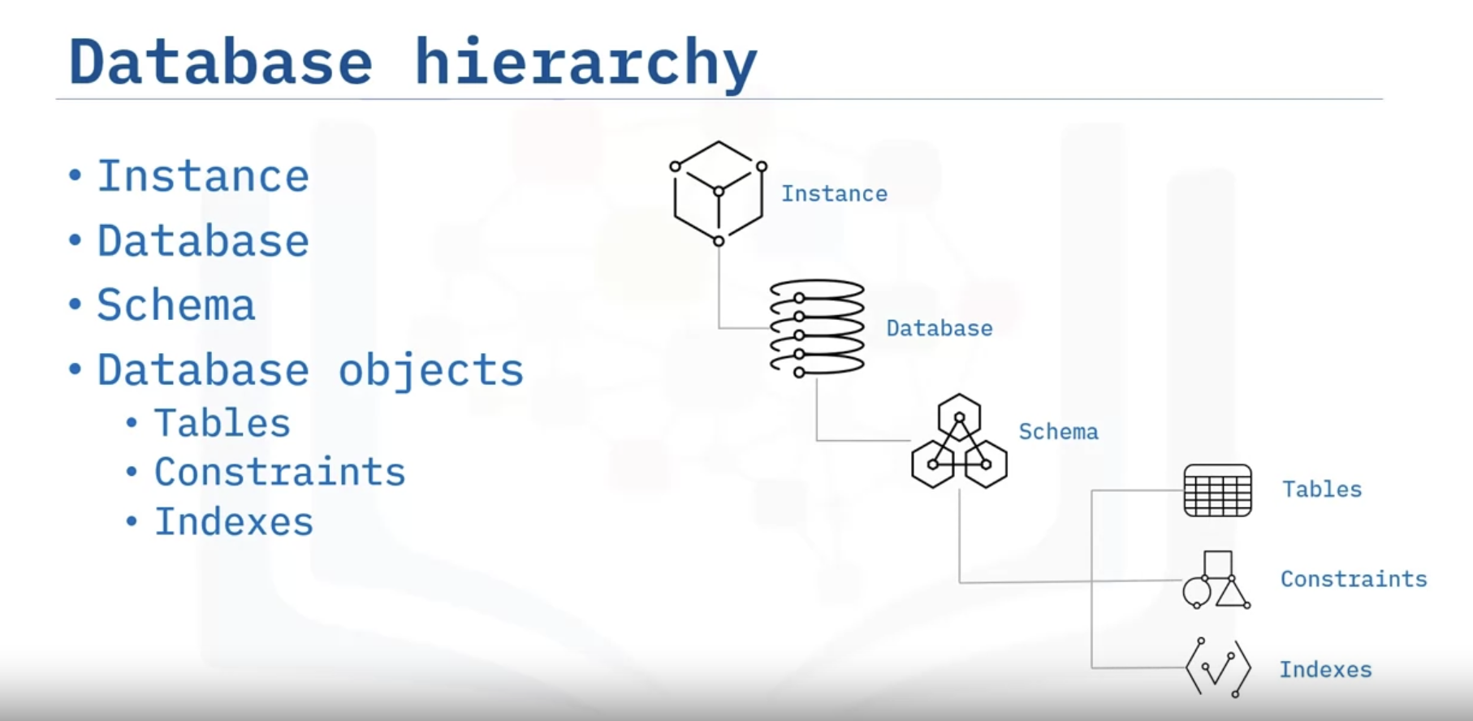

* An instance(server) is a logical boundary for a database or set of databases where you organize database objects and set configuration parameters.
* A relational database is a set of objects used to store, manage, and access data. Relationships between tables to reduce redundant data and improve data integrity.
* A schema is a specialized database object that provides a way to logically group tables, views, nicknames, triggers, functions, packages, and other database objects. Schemas provide naming contexts so that you can distinguish between objects with the same name.
  + User schemas contain database objects like tables, views, functions.
  + System schemas contain configuration information and metadata for the database.
* **Database partitions**. You can split very large tables across multiple partitions to improve performance.
* **Database objects**. Database objects are the items that exist within the database, such as tables, constraints, indexes, views, and aliases.

**Primary Keys and Foreign Keys**

* You can use primary keys to enforce uniqueness of rows in a table
* Foreign keys are column in a table which contain the same information as the primary key in another table
* You can use primary and foreign keys to create relationships between tables

**Overview of Indexes**

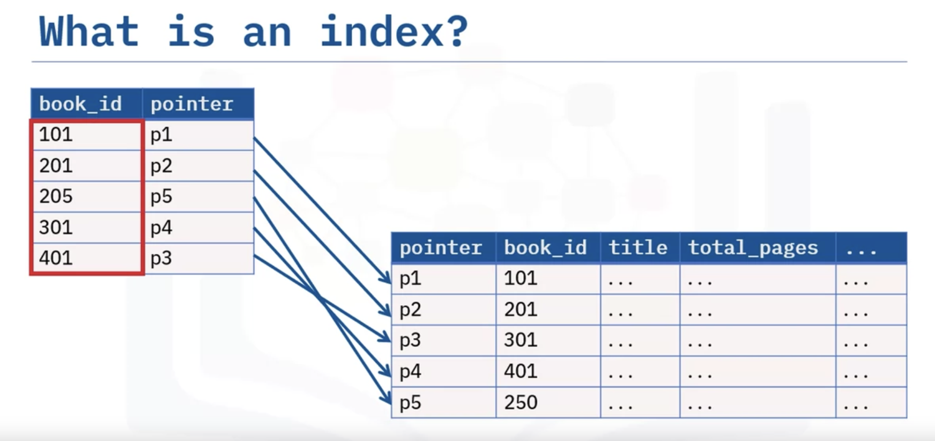

* Indexes provide ordered pointers to rows in tables,
* Indexes can improve performance of SELECT queries,
* Indexes can decrease performance of INSERT, UPDATE, and DELETE queries.

**Normalization**

* Normalization reduces redundancy and increases consistency of data
* In first normal form (1NF), each row must be unique, and each cell must contain only a single item.
* In second normal form (2NF), you must create separate tables for sets of values that apply to multiple records.
* In third normal form (3NF), eliminate any columns that do not depend on the key.

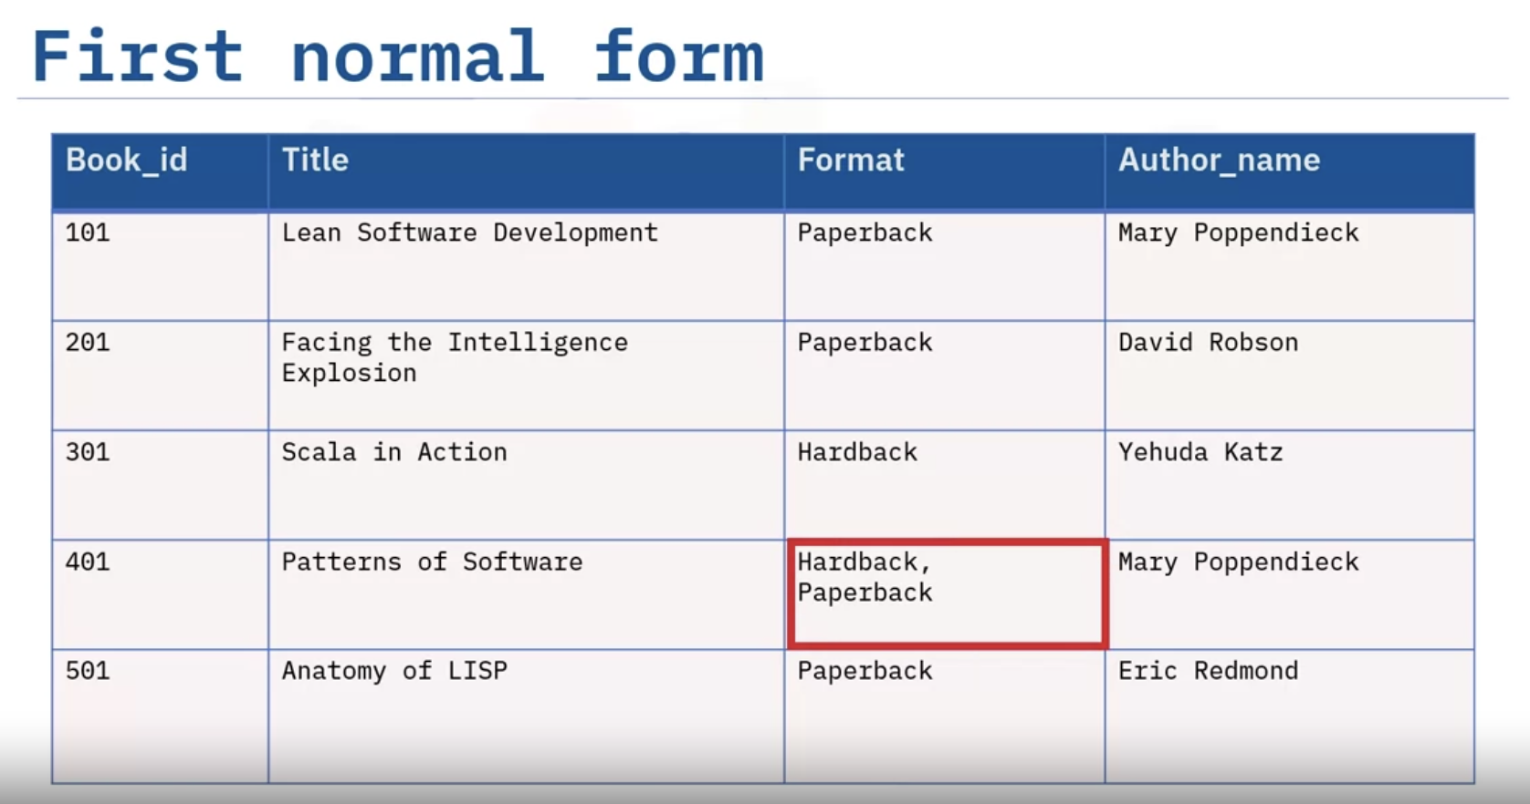

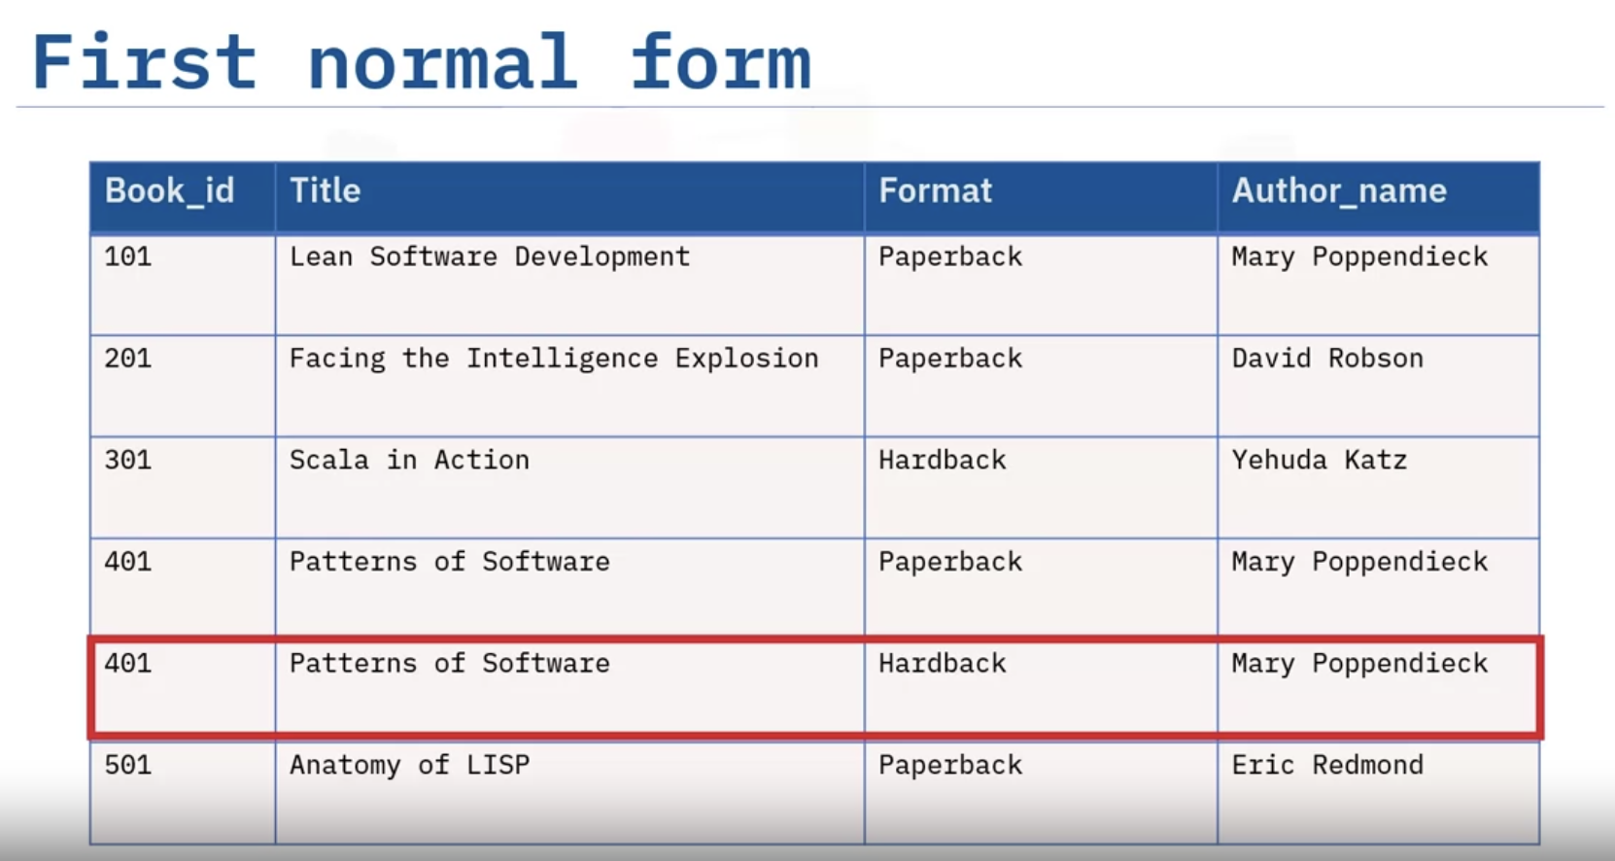

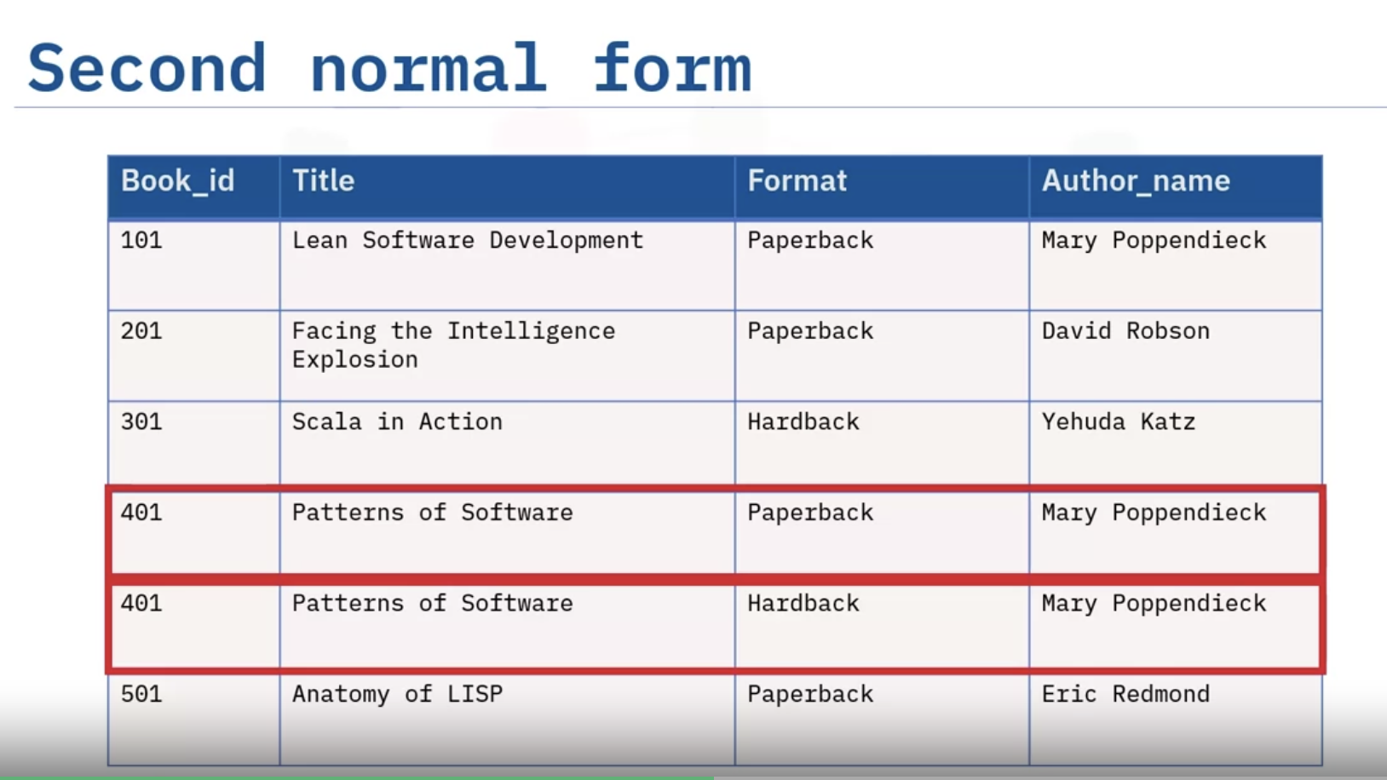

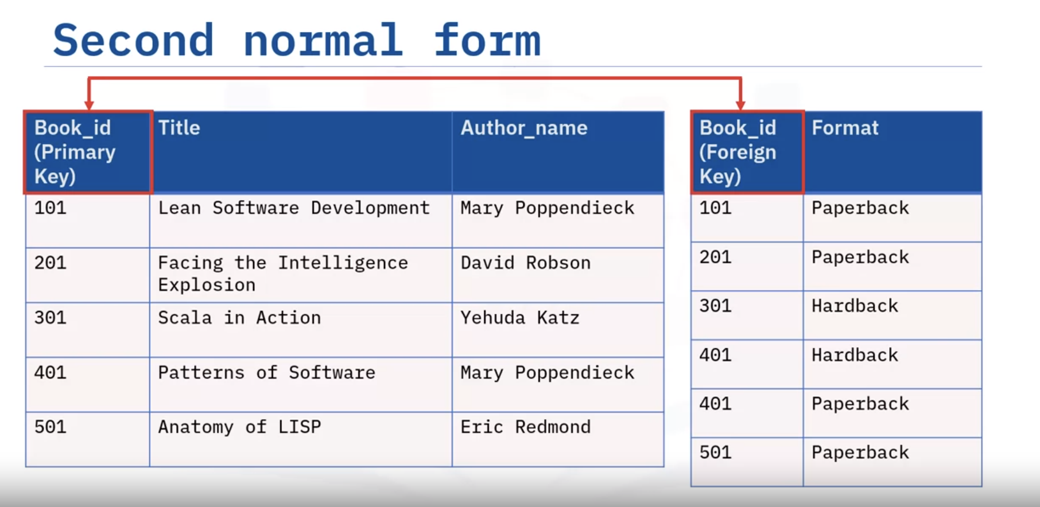

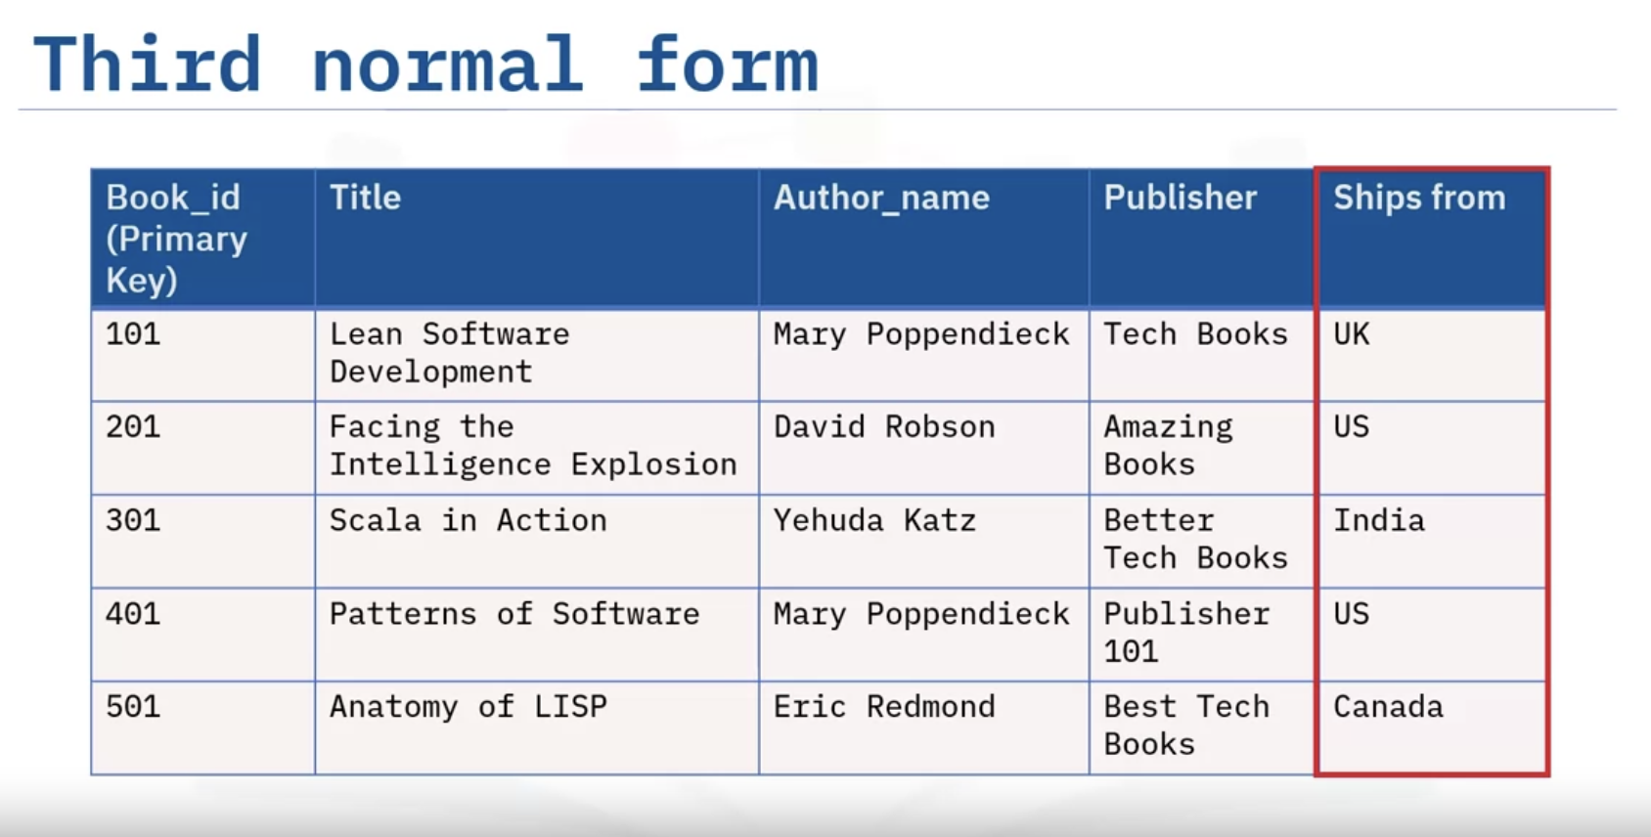

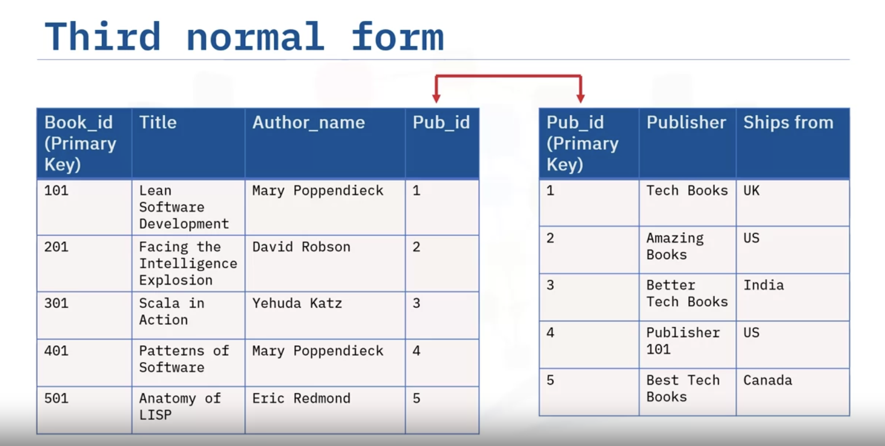

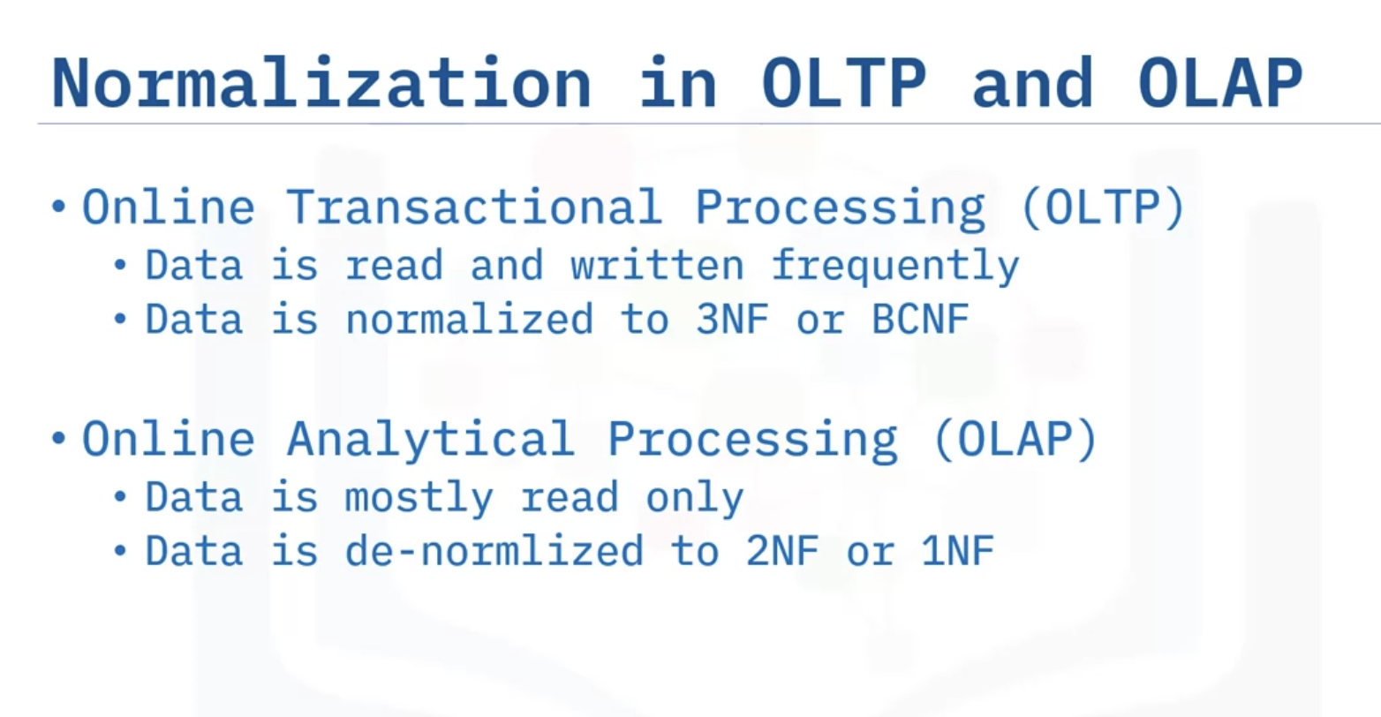

**Relational Model Constraints – Advanced**

* Entity Integrity Constraint ensures primary key is a unique value that identifies each tuple (or row)
* Referential integrity constraint defines relationships between tables
* Semantic Integrity Constraint refers to the correctness of the meaning of the data
* Domain Constraint specifies the permissible values for a given attribute
* Null Constraint specifies that attribute values cannot be null
* Check Constraint limits the values that are accepted by an attribute

**MODULE 3 – MySQL & PostgreSQL**

**MySQL**

# **Getting Started with MySQL**

* You can download and install MySQL on your own desktop servers
* You can self-manage or use managed services for MySQL in the cloud
* mysql and mysqladmin are command line interfaces for database management
* MySQL Workbench is a desktop application for designing, developing and administering MySQL databases
* phpMyAdmin is a web interface for working with MySQL databases

# **Creating Databases and Tables in MySQL**

* You can use a command line interface, a graphical user interface, or API calls to create databases and tables in MySQL
* phpMyAdmin provides an easy-to-use interface to create databases, tables, and columns
* You can add and modify columns after you create a table

# **Loading Data in MySQL**

* You can use backup and restore functionality at the command line and in phpMyAdmin to populate databases
* You can use manually insert small amounts of data using phpMyAdmin
* You can use import and export functionality at the command line and in phpMyAdmin to populate tables and save their data to files.

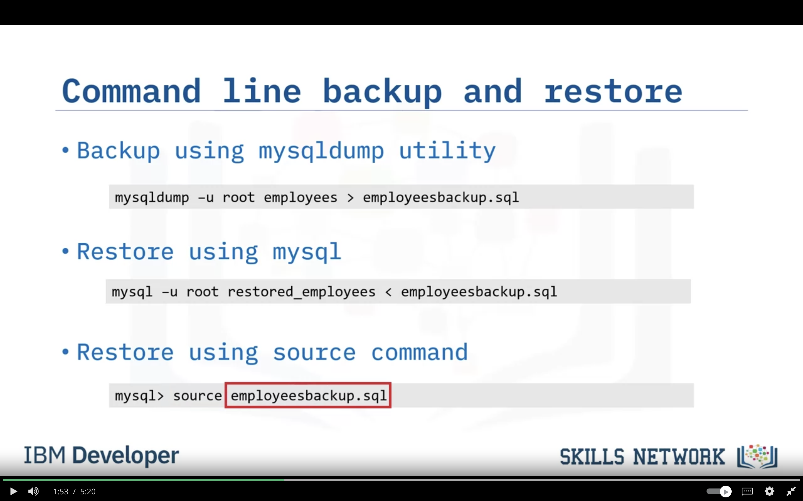

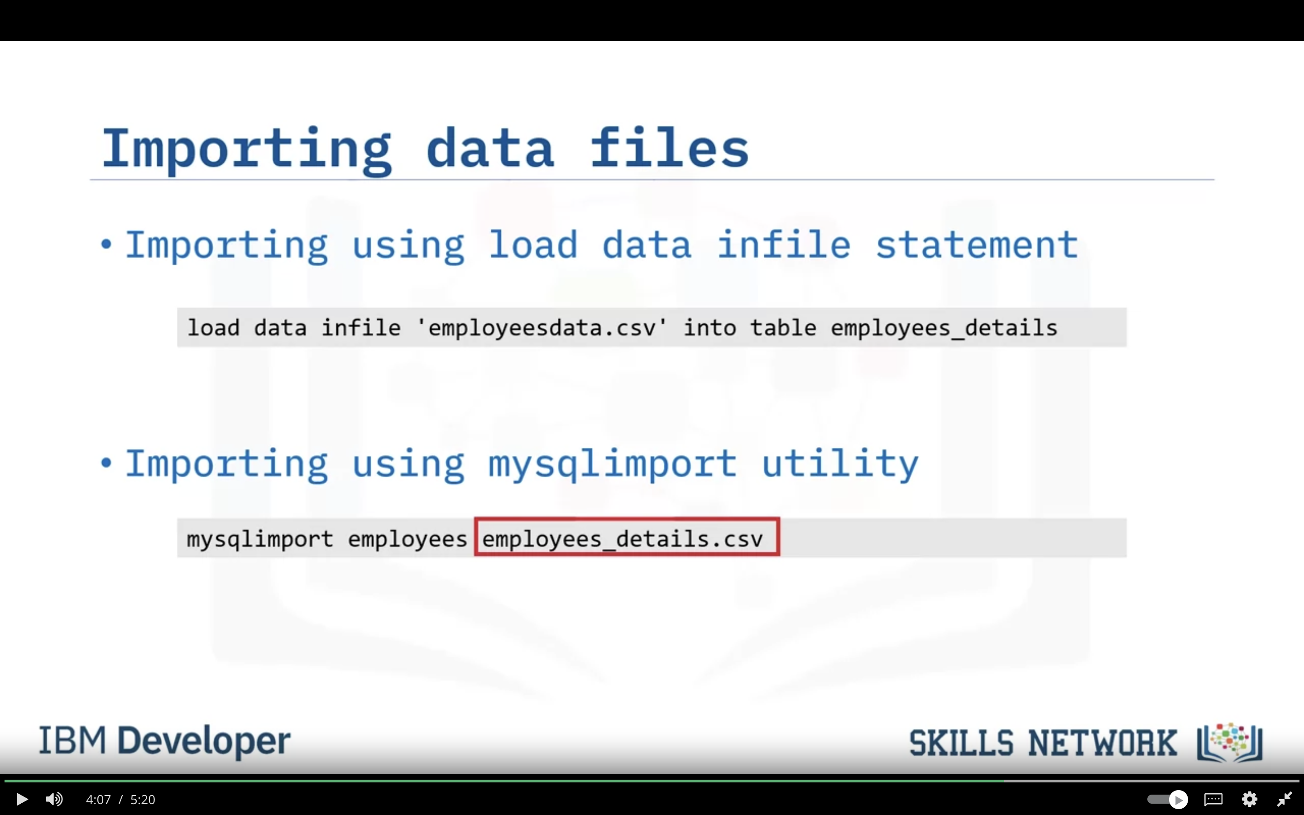

Password to connect db in handson: MTc1MTgtbXM2Ynot

**Using Keys and Constraints in MySQL**

* You create primary keys by defining a primary index on one or more columns
* You use autoincrement to automatically generate sequential numeric data in a column
* When creating foreign keys you can define ON DELETE and ON UPDATE actions
* MySQL columns are NOT NULL by default
* You can configure a column to only accept unique values

**Note**:

**Primary Keys**: A primary key is a column or group of columns that uniquely identify every row in a table. They constrain the table by only accepting unique, non-NULL values for that column. Non-NULL data is data where the values exist.

Creating a primary key on a table automatically creates an index on the key.

**Auto-increment**: Auto-increment enables a unique number to be generated automatically when a new record is inserted into a table. Often this is used for the primary key field to be created automatically every time a new record is inserted. You will set the auto-increment feature for the primary key of the author table.

**Null constraints**: By default, a column can hold NULL values. If you do not want a column to have a NULL value, you can restrict the column from having a NULL value. You will restrict the first_name column of the authors table from having a NULL value.

**Foreign keys**: A foreign key is a column that establishes a relationship between two tables. It acts as a cross-reference between two tables as it points to the primary key of one table (the parent table), constraining the data in another table (the child table) by the data in the parent table.

**CASCADE** means that when rows are deleted or updated in the parent table, the corresponding rows in the child table will also be deleted or updated.

**RESTRICT** means that rows cannot be deleted or updated in the parent table if there are corresponding rows in the child table.

**PostgreSQL**

**Getting Started with PostgreSQL**

* You can install PostgreSQL on your own servers or work with it in the cloud
* psql provides a command-line interface to a Postgres server
* pgAdmin is a popular database management tool for PostgreSQL which includes object navigation, the Query Tool, and the ERD Tool

**Creating Databases and Loading Data in PostgreSQL**

* You can use many tools to create PostgreSQL objects, including the psql command line utility and pgAdmin
* You can use pg_dump to back up databases and psql to restore them
* You can use the pgAdmin Import/Export tool to load data into and export data from tables

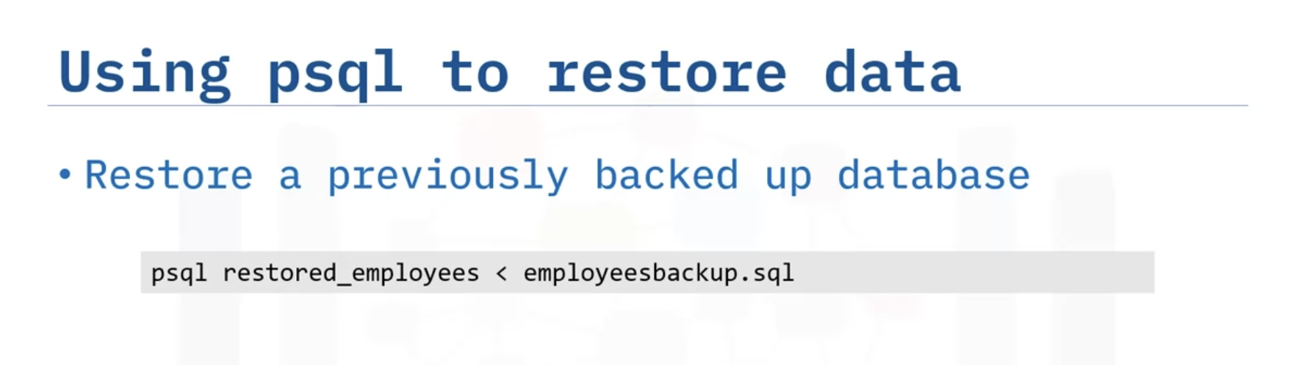

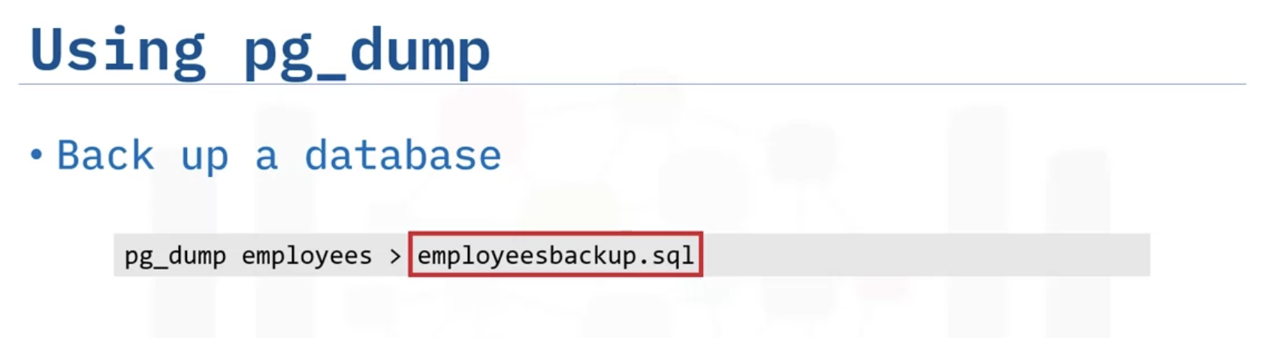

**Views**

* Views are an alternative way of representing data
* You can use views to limit access to sensitive data and simplify data retrieval
* Materialized views store the result set for quicker subsequent access
* You cannot insert, update, or delete rows via a materialized view

**Summary**:

PostgreSQL is an open-source object-relational database management system that you can download and install on your own systems or access on the Cloud.

You can either self-manage a Cloud instance of PostgreSQL or use a managed services provider, including IBM Cloud Databases for PostgreSQL, Amazon RDS, Google Cloud SQL for PostgreSQL, EnterpriseDB cloud, or Microsoft Azure for PostgreSQL.

PostgreSQL includes several options for creating databases and tables, loading and querying data, and importing and exporting data relational databases:

* The psql command line interface. You use this CLI to run SQL statements.
* pgAdmin. A graphical interface to the database server, which is available as a desktop application or as a web application that you can install on your web servers.
* Navicat and Dbeaver. Commercial graphical interface options that you can use to access PostgresSQL, MySQL, and other types of databases.
* Cloud vendor tools and APIs.

Using pgAdmin, you can:

* Use pg_dump to back up databases and psql to restore them.
* Use the Import/Export tool to load data into and export data from tables.

Using views:

* You can use views to limit access to sensitive data and simplify data retrieval.
* Views can be materialized, which means that the view store the result set for quicker subsequent access.
* Materialized views enhance performance because the view is saved and often stored in memory. However, you cannot insert, update, or delete rows in a materialized view, and they must be refreshed before you can see updated data.

**Module 4**

**ASSIGNMENT**

**Approach to Database Design (Including ERD)**

* It is important to spend time designing your database before you start the implementation
* There are three stages of database design: requirements analysis, logical design, and physical design
* Using an ERD designer can simplify the design process

**Project**:

Designed ERD in PgAdmin tool by using data given in course and performed Normalizations and finally created schema & loaded data as given in assignments.

Finally created views and then loaded into IBM DB2 console. Similarly, materialized view into PhpMyAdmin.